

PROJECT DEVELOPMENT REPORT

E-LIBRARY

GROUP NAME : BORDERLANDS

SYED ZAIMI PUTRA AL-JAMALULLAIL BIN SYED YUSOFF

1728655

RIHAB ADIB BIN OTHMAN

1717405

MUHAMMAD KAMIEL BIN SAMSUDIN

1713493

ABDUL RAHMAN BIN AHMAD

1721823

**1.1** **INTRODUCTION**

E-Library is a web application that provides a platform for everyone either student, lecturers or even public users. Some of the specifications that we planned to do is divided into 2 perspective. From admin and from user perspective. From admin, they can login and logout, add/edit/view/delete books from the database. From user perspective, they can browse, borrow and return books.

**1.2 PROBLEM DESCRIPTION**

**1.2.1 Background of the problem**

We are going to do web application. The users are mainly those who regularly come to the library looking for books they desired for academic or leisure purpose. Sometimes these people come all the way from their home or college just to find that their desired books is not available.

**1.2.2 Problem Statement**

Manual borrow system. Monitor the availability of books in the library. Ease librarians to add and remove books from database and library.

**1.3** **PROJECT OBJECTIVE**

We aim to develop an autonomous system for library user and admin for them easily manage the flow of browsing, borrowing, and returning books to the library. The application will show and notice the borrower how long they can have the books before returning it. Also, the system can give notice to admin showing which book is currently not available.

**1.4 PROJECT SCOPE**

**1.4.1 Scope**

This system will include online browsing in the library environment. Searching for books, journals, textbooks, thesis etc. and borrow/return system with time and dates. This application should allow users to

· View list of books

· Select books to borrow

· Check borrowed books and the max return date

· Add//remove books from the database

**1.4.2 Targeted User**

Library users -Youth, students (age 14-30)

-Researcher (age 30-80+)

-Library admin/staff

**1.4.3 Specific Platform**

Our application requires Windows OS to develop because of the various software that is needed such as JDK, MySQL and Visual Studio Code. We also require a computer capable of multithreaded applications to handle our web application. Regarding limitations, we do not have a dedicated server to host our database so all data is stored locally, which impedes our development because we must share one computer to access the data.

**1.4** **CONSTRAINTS**

One of the constraints that we face is time. The project was given near the examination time. Investing.our time to finish the codes and finish the design is one of our challenges.

We also faced difficulties in segregating our tasks. Having everyone to work on a controller, model and view is not an easy fit. Therefore we really needed to have an application that is enough for all of us to do.

**1.6 PROJECT STAGES**

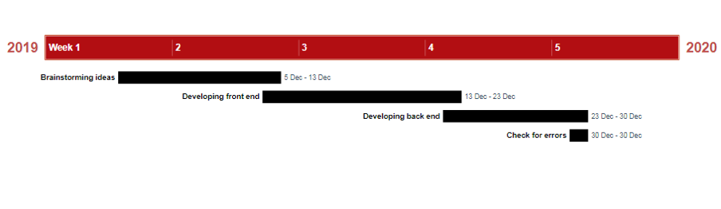

**1.7 SIGNIFICANCE OF THE PROJECT**

The process of borrowing/returning books will be much faster. Reduce the amount of late return. Easy monitor the current availability and adding new books to the system. Ease the process of browsing desired books.

**1.8 SUMMARY**

Overall, our system named E-library, a system that technically helps everyone involve in library matter such as user of library and admin. Borrowing and returning process for user side while management of books availability for admin side.

**2.1 CODES AND FUNCTIONALITIES**

***Login.jsp***

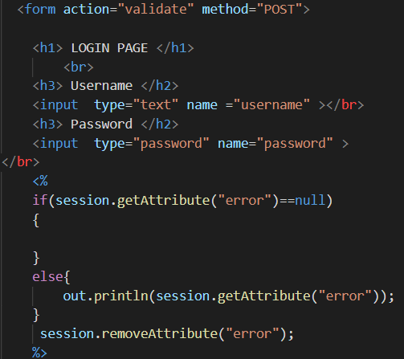

Figure 2.1: Login form

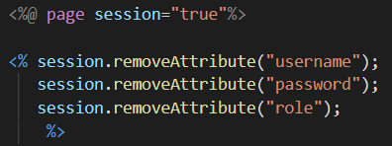

Figure 2.2: Remove previous session/reset session

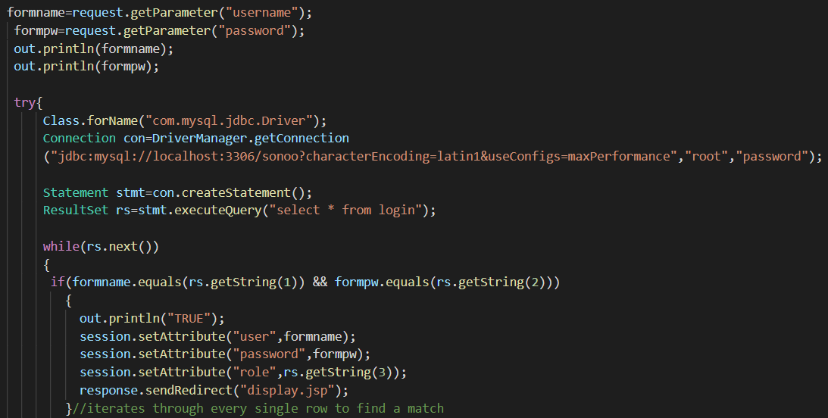

Figure 2.3: Servlet that fetch data from login and check with database

***Mainpage.jsp***

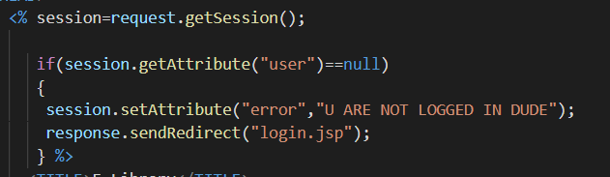

Figure 2.4: This part of the code is to verify the login credentials from login page. If user is empty(null) it will redirect to login.jsp with message printed.

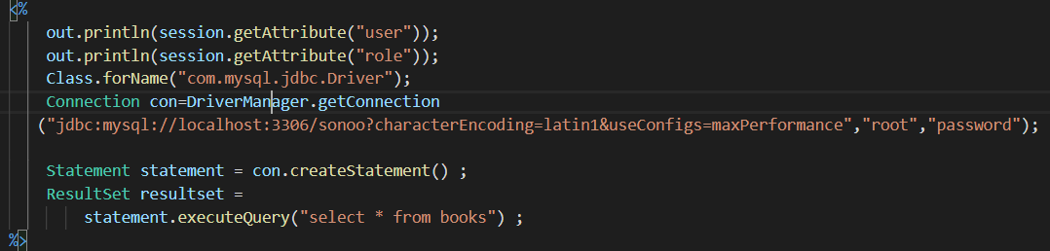

Figure 2.5: Establish connection to the database. Creating statement and connection object.

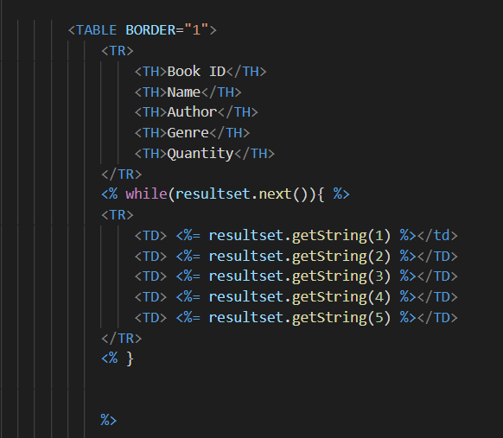

Figure 2.6; Retrieve all data from database and display it on page.

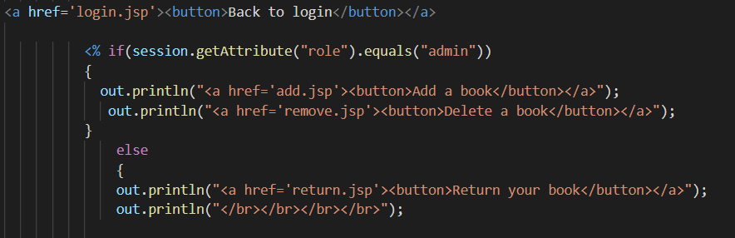

Figure 2.7: Back button to login.jsp. If-else statement to decide which button should be displayed based on the role logged in. If admin, the main page will display button to ‘add book’ or ‘delete book’ If user, the main page will display ‘return book’ button.

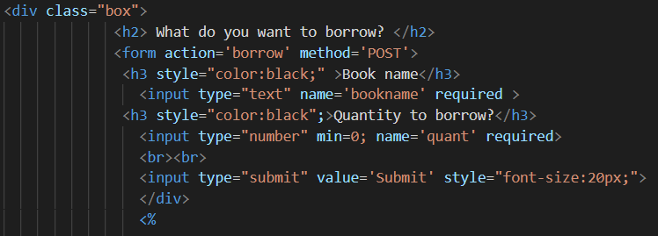

Figure 2.8: An area below the available books that displays the form for user to borrow any books by entering the name of the books and quantity.

***Borrow function***

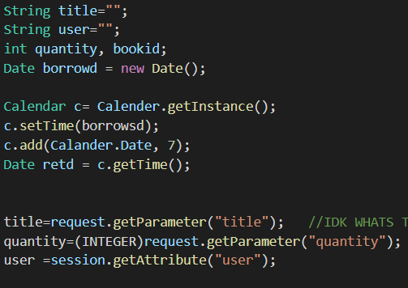

Figure 2.9: Variables needed for borrow functions. (title, user name, quantity, and date)

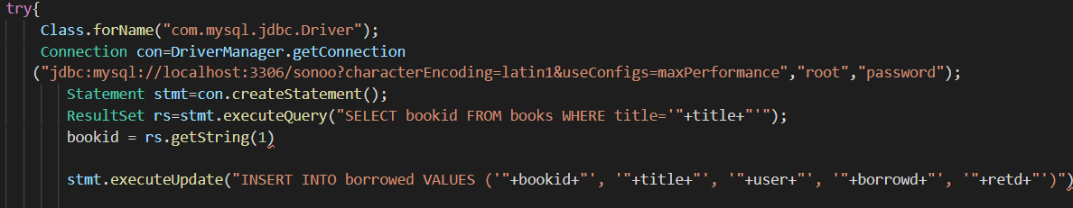

Figure 2.10: Insert statement to database

***Return function***

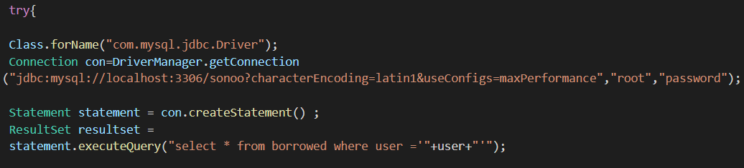

Figure 2.11: Fetch the data from database if the user have borrowed books that can be returned

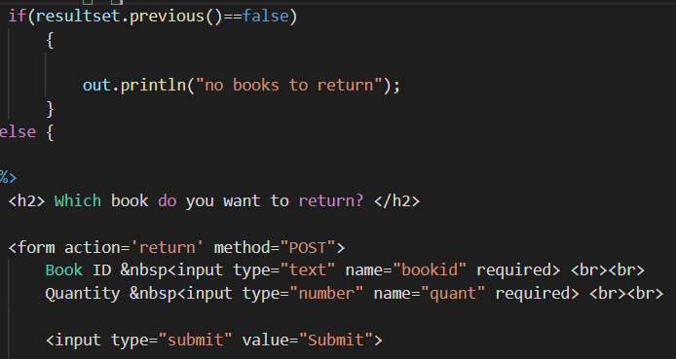

Figure 2.12: If no books, display message. Form to return books. Information needed are book ID and quantity.

***Add function***

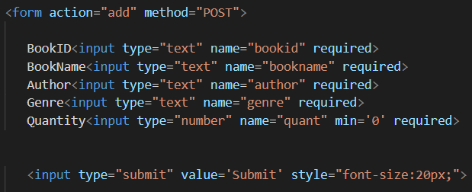

Figure 2.13: Add books form that can be used by admin only

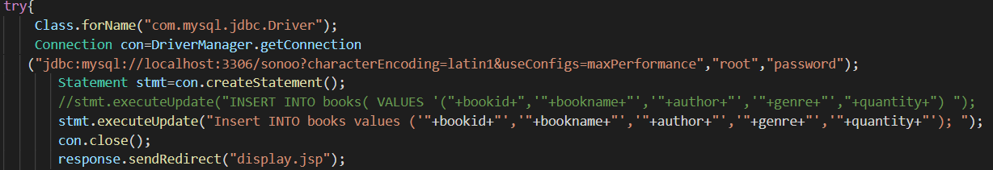

Figure 2.14: Servlet that have statement to add books to database.

***Remove function***

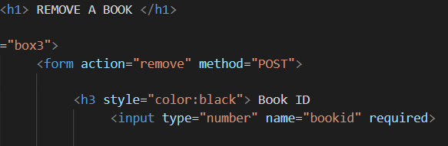

Figure 2.15: Same as add function, remove form only can be used by admin. Only require book ID

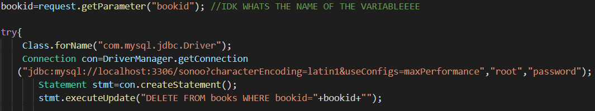

Figure 2.16: Servlet that have statement to remove books from its database

**\*\*The code implementation and its completed functionalities and proposal together with the developer names as final report submission must be uploaded to GitHub.\*\***